Update iTopia Rule

Jason Chen

May 10, 2019

For RLS-445554, TST-446876 [DDCFUN-20] (S028), this document provides detailed instructions of removing the settings of DefaultReleaseForPutaway from iTopia rule wms_pm_f.item_update_ldb:

In WMS, go to Rules, and search for Table Name = pm_f:

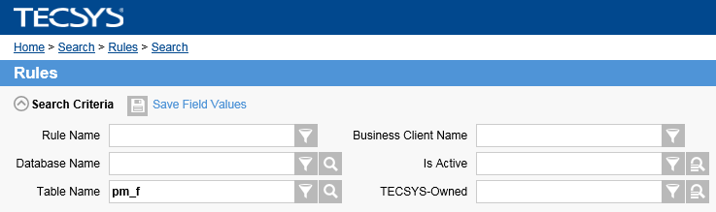

Go into the details page of rule wms_pm_f.item_update_ldb:

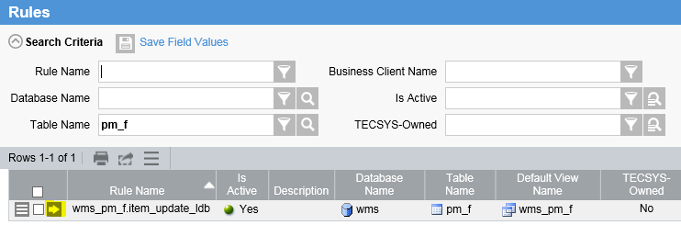

Click the Maintain Rule button:

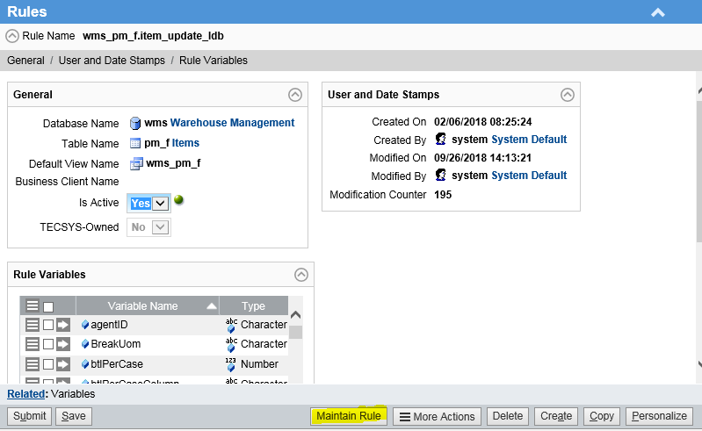

Click the Expand All button (this takes a while to complete):

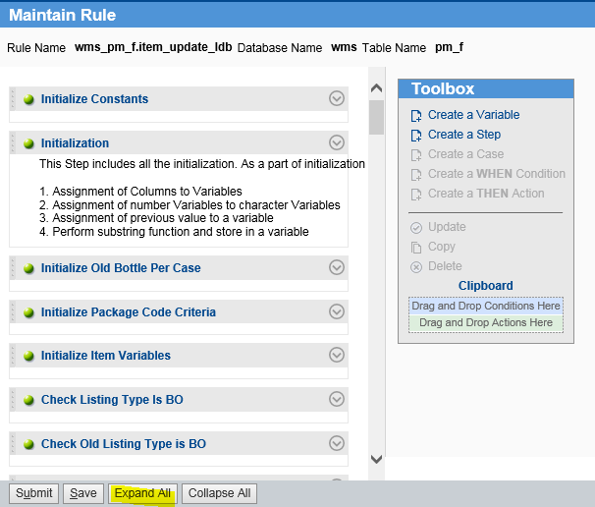

Do ctrl-f and find “Putaway”. 4 matches should be found. Each of the matches assigns a value to field “Default Release for Putaway”. Delete the settings as follows:

1. For step “LT Change: Update Configuration”, delete:

* Assign Y to Default Release for Putaway
* Assign N to Default Release for Putaway

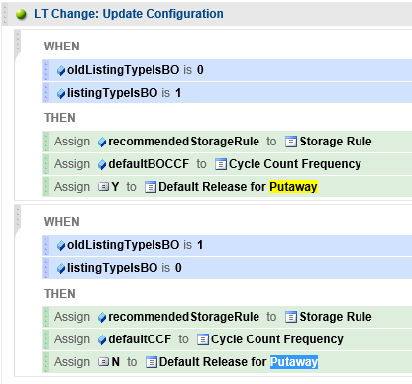

1. For step “New Item – Set LT Specific Setup”, delete:

* Delete: Assign Y to Default Release for Putaway
* Delete the WHEN… block that contains “Assign N to Default Release for Putaway”.

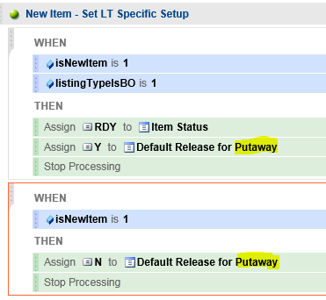

Save and Submit the changes.